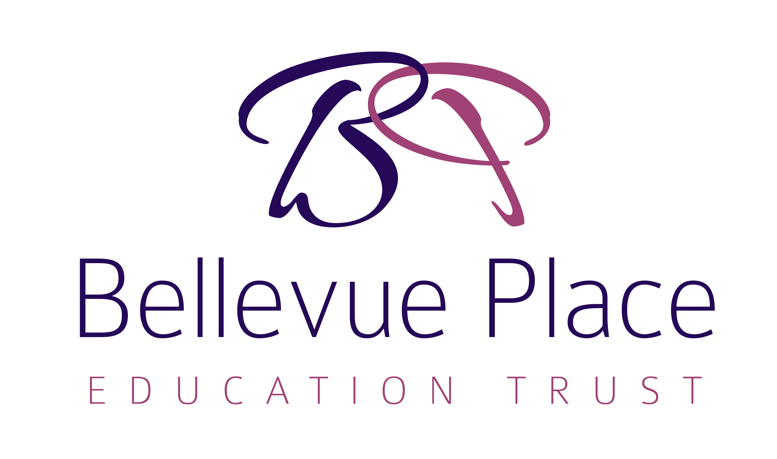

BPET Behaviour Policy

Signed: | 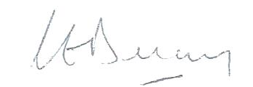
Chair of Trust Board: | Claire Delaney
Signed: | 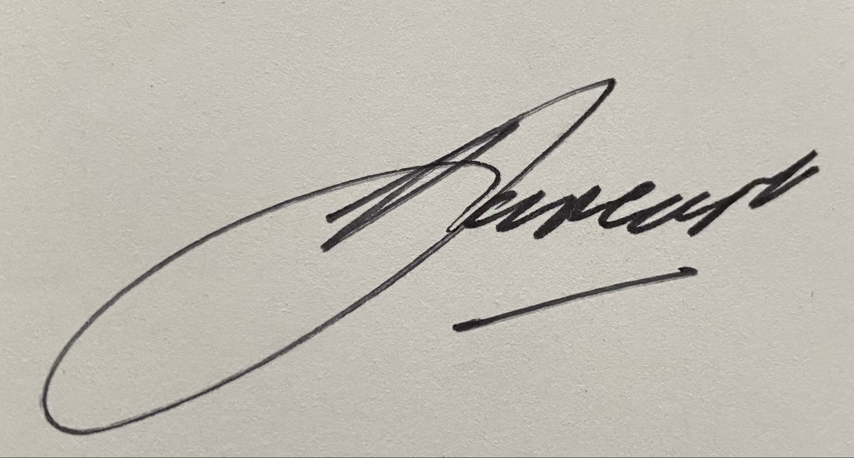
Local Advisory Board Member: | Ann Jansen-East
Approved: | 1 September 2020
Renewal: | Every 2 Years
Review Date: | September 2022

Bellevue Place Education Trust – Our commitment

Learn. Enjoy. Succeed.
Every BPET child and staff member enjoys a broad (LEARN) and enriched (ENJOY) learning experience, enabling them to achieve far greater individual success (SUCCEED) than they might previously have thought possible.

Our Mission To grow hubs of like-minded, autonomous schools, well-supported, all of which combine academic rigour with highly enriched opportunities that deliver a personalised approach to education and exceptional outcomes for all.
Our Difference We are leading the way in delivering high quality education through a skills-based curriculum, applying the best of the independent and state sectors to deliver breadth of opportunity and pupil enrichment. We empower all our schools as individual entities that best meet the needs of the communities they serve and have a strong relationship with parents, who are our key partners in delivering the vision.
Our Promise Every child is an individual. Our role is to nurture pupils’ potential through a personalised approach to learning. BPET children are happy, independent, confident all-rounders. We encourage a ‘be interested and be interesting’ attitude in children and staff alike. We don’t just teach; we want our pupils to have a passion to learn. Our focus is on all pupils, regardless of background or academic ability, focusing on pupils with Special Educational Needs as well as those who are more-able.

Introduction
The school consider it is vitally important to promote a caring and supportive environment to enable all members of the school community to feel secure and respected, and therefore promote good behaviour in others.

This policy follows the guidance set out in the Equality Act 2010.
This policy is written with due regard to the DfE guidance ‘Behaviour and Discipline in Schools’ 2016 and the requirements of the EYFS Framework 2017.

It recognises the duty of proprietors under Section 7 of the Education (Independent School Standards) Regulations to ensure that arrangements are made to Safeguard and promote the welfare of children.

Headteachers and their staff have the authority to discipline pupils for their behaviour in school and, in some circumstances, outside of school. This includes the authority to impose sanctions appropriate to the age and action of the child, including detaining children beyond the school day and confiscation of property, fuller details of sanctions employed by the school and their application are included in this policy.

Teachers may discipline pupils for non-criminal bad behaviour off-site, under the following circumstances (from DfE guidance, January 2016)
- misbehavior when the pupil is:
  - taking part in any school-organised or school-related activity or
  - travelling to or from school or
  - wearing school uniform or
  - in some other way identifiable as a pupil at the school.
- or misbehaviour at any time, whether or not the conditions above apply, that:
  - could have repercussions for the orderly running of the school or
  - poses a threat to another pupil or member of the public or
  - could adversely affect the reputation of the school.

Coronavirus (COVID-19)

Pupils and parents should be made aware that this policy and its sanctions apply if and when pupils are working in a virtual environment outside of the normal school setting.

Aims and Objectives
The development of personal qualities and social skills and the fostering of socially acceptable behaviour are integral aspects of the school curriculum and therefore demand planning, tracking, recording and evaluating as part of the goal we have for high standards of conduct by means of encouraging personal development in pupils.

We aim:
- To ensure consistency and care;
- To be fair and be seen to be fair;
- To treat all with respect;
- To have clear expectations and strategies to ensure they are met;
- To build and rebuild self-confidence self-esteem and self-respect in pupils;
- To provide planned activities which motivate pupils academically and socially.
These objectives for behaviour are derived from the aims listed above.

4.0 General Approaches to behaviour management
The goal of this policy is to support children in developing the self-awareness and self-discipline that allows them to recognise positive behaviour and moderate misbehaviour independently.
The school undertakes the following in the context of its policy, acknowledging its legal duties, in respect of the Children Act 1989, Equality Act 2010 and Special Needs requirements, to
- Reject any form of corporal punishment, including the threat of corporal punishment. Furthermore, children should not be subjected to sanction that may adversely affect their well-being.
- Work in partnership with parents to ensure that
  - they are kept informed about disciplinary issues and rewards for good behaviour relating to their child
  - they can work together with the school to achieve improvements in their child’s behaviour when expected standards are not met.
- Ensure the safeguarding of and respect for pupils with SEND
- Make reasonable adjustments in behaviour management in respect of the understanding and capabilities of pupils with SEND
- Ensure any sanction does not breach any other legislation and is reasonable in all the circumstances.
- Consider whether the behaviour is related to a potential safeguarding issue, that may result in significant harm to the pupil. In such a situation, the school will make reference to the Safeguarding Policy.
- Consider if behaviour issues are the consequence of an unmet educational or other need; requiring a behaviour review or possible multi-agency or specialist assessment, with reference to the SEN policy
5.0 Rewards and Sanctions
The principles on which the school has developed its rewards and sanctions strategy are as follows
- Expectations are reasonable for pupils of all ages and needs
- The priority is the promotion of positive behaviour
- Support the teaching of good behaviour, self-discipline and respect
- Designed through pupil discussion
- Enable independent pupil action and reflection
- Support positive relationships in school
- Reinforce and reward appropriate behaviour
- Enable staff to develop classroom management strategies, including the organisation of facilities and resources
The school acknowledges that children require a range of approaches for successful behavior management and therefore reasonable adjustments will be made where appropriate. For example, the policy and procedures may be amended where necessary for EYFS or children with SEND.

Conventions for social development represent the unwritten rules by which a learning community manages reasonable behaviour which has the good of the community uppermost.

Social conventions that we follow will be consistent with the following precepts:

- We understand it is normal to make mistakes;
- All should be sensible, thoughtful and kind to others;
- We should think before we speak or act;
- We should walk calmly around the building and grounds to be safe;
- We should help each other and get on with everyone;
- We should be respectful to others;
- We should tolerate reasonable difference and celebrate diversity.

In Braywick Court School if a child successfully applies these conventions, this should be acknowledged. In our school we believe the ideal incentives are the intrinsic rewards offered by:
(i) Warm relationships;
(ii) A stimulating and tolerant social environment;
- Positive role modeling;
- Doing what is right.

However, it is also important to have a reward system in place which recognises all forms of social and academic achievement and effort. To ensure every child has the opportunity to experience success we use the following as rewards.

- Non-Verbal Praise:
Smiles, thumbs up and nods of approval.

- Verbal Praise:
We believe that verbal praise is a most important factor in creating positive atmospheres which will promote good behaviour. Verbal praise can range from a word in the ear to a `public' recognition in class. It can also be given to and by everyone.
Praise is often most effective when it is specific to something the child has done well. For example “Well done for helping your friend when they fell down, that was kind.” “Your handwriting is much neater today, keep up the good work.”

- Marking Policy:
Within class the way we mark as part of formative and summative assessment within Assessment for Learning will be used to build on success and provide encouragement by its associated comments and feedback, this will include behaviourally relevant aspects such as calm quiet effort and perseverance.
Verbal feedback will be given regularly, celebrating the specific things children have done well in their work, where and how they have met the learning objective and highlighting where improvements have been made.

- Privileges or Jobs:
Within each class there will be roles perceived by the children as the giving of responsibility as rewards.
Positions of responsibility will also be given across the school and it will be made clear to the children that these positions are a privilege given to those who are considered reliable and trustworthy. Some of these responsibilities will involve an application process.
Responsibilities include:
- Buddy for younger children
- Line leader
- Ambassador
- Librarian
- Sports Leader
- House Captain
- Head boy and Head girl
These additional responsibilities will be celebrated with the children. They will be praised for doing a good job and encouraged to take on these additional leadership responsibilities.

- Class rewards:
Children will be rewarded with a variety of other forms of recognition for good behaviour. Each class will have their own system for this which is age appropriate and personal to the staff and children.
These may include, but are not limited to: a behaviour chart, stickers, certificates, notes home, team points, house points.

- Sharing:
In recognition of a particular task or behaviour the pupil may share their success with others, for example:

- The class;
- The neighbouring class or teacher;
- A chosen adult.
- The Head Teacher – for a Wow card

- Whole school rewards:
- House points are a key part of our behaviour system. Points can be awarded for a variety of reasons including: good work, good behaviour, being kind and helpful. House point totals will be announced in assembly and in the newsletter every Friday. The winning house will have a celebration at the end of the school year.
- Celebration assembly takes place for the whole school every Friday. A variety of awards may be given. Stars of the Week are awarded each week for each class. These are also celebrated in the weekly newsletter.

6.0 Consistency
The school is committed to achieving a consistent response in the management of behaviour, this is achieved through
- Staff training, support and development
- The induction of new staff
- Monitoring of consistency in behaviour management by the head/SMT
- Clear and consistent boundaries for classroom management developed in conjunction with children
- Monitoring of logs of administration of disciplinary sanctions

Disincentives to Poor Conduct
If a child breaks any of the social conventions there will be a sanction. It is our belief that sanctions consistently and firmly applied will result in boundaries being clearly drawn and therefore good behaviour promoted. We consider it vitally important to remember at all times to identify early and target the behaviour, and not the child. As with the incentives, there will be different levels.

- Non-Verbal Signal:
Holding eye contact, a shake of head, a slow walk to the child and remaining in proximity using position as a non-verbal signal.

- Verbal Signal:
Usually this will be a reminder of the social conventions. At this stage it is usual that this will be in a 1:1 situation, quietly without the rest of the class becoming distracted.

- Verbal Warning:
A clear concise message. “`X', if you carry on with `Y' behaviour then `Z' will happen.”

- Time Out:
A child will be required to move from their seat to a space available, where they will receive a clear explanation of the behaviour required for them to return to their original seat. This `behaviour' may be the completion of task or a time period of appropriate action. For BPET schools this will be seen as an opportunity to rebuild positive relationships after a minor incident and will always be followed up with a conversation with an adult about making better choices next time.

- For more serious or repeated misbehaviour, the pupil may be referred to the Phase Leader, who has oversight of the school pastoral care framework and who will decide on an appropriate course of action bearing in mind any investigation into events that may be needed and the particular context of each individual incident. From this stage onwards information about the incident(s) will be recorded on the child’s file.

- We do not anticipate escalation to fixed term or permanent exclusion but if an incident warrants this level of consideration by the Headteacher then we will abide by all statutory and allied best practice requirements regarding exclusions.

In all the above strategies once the child has successfully completed their sanction, their modification of their own behaviour will always be acknowledged positively by school staff.

Behaviour charts
For a number of children, behaviour charts with sanctions and rewards agreed with parents can be highly effective. These are put in place by a member of SLT following consultation with teachers.
This is used as a form of support for the child, ensuring that the school and the family work together to promote positive behaviour. They will be time limited and success will be measured and reviewed with the child and parents or carers.
8.0 Confiscation

Teachers are authorised to confiscate items which pupils should not have in their possession at school. In such circumstances, staff may follow one of the following options in relation to the confiscated items;

- returning items to pupils or parents after a given period (where possible at the end of the school day)
  - for example, items banned from school, such as money, mobile phones, specific toys
- destroying items
  - for example, pornography, tobacco, alcohol
- handing items to the police
  - for example, banned substances, knives and weapons, stolen items

In this context, the school has regard to the DfE guidance “Screening, Searching and Confiscation – advice for head teachers, staff and governing bodies”.
9.0 Additional Strategies
The school has processes in place to support pupil’s behaviour where the usual rewards and sanctions strategies are not working.
10.0 Transition
Pupils will be supported in transition into school, between year groups and to secondary school through a planned transition programme. This will include meeting their new teacher and receiving information for parents about the expectations of the new setting or year group.
11.0 Physical Restraint
Corporal punishment is not used or threatened, nor any punishment which may adversely affect a child’s well-being.
Physical contact may be used appropriately to comfort children who are hurt or upset. Be clear that this is being done for the good of the child. This should be done for as short a length of time as possible.

Physical contact can be appropriate in certain circumstances. For example, administering first aid, demonstrating how to point the toes in ballet by holding the child’s foot.
In such circumstances, follow this guidance:
- Public place, not one to one situation
- Having consent of the child before you do it
- Justification must be that it is for the child’s benefit

Physical intervention or restraint should be avoided and only used to avoid danger. For example:
- Taking a child’s hand to prevent them from touching something hot or running into the road
- Physically stopping a child from throwing something or physically hurting someone else.

Under these circumstances physical restraint is allowable. It is essential that incidents are promptly reported to SLT so that it can be recorded appropriately. You should also ensure that parents are informed on the same day or as soon as reasonably practicable. (Refer to Positive Handling Policy which includes a proforma for recording incidents and a risk assessment form)

12.0 Curriculum
The school will promote positive behaviour through the curriculum integrating the following elements into the taught and co-curriculum, as well as assemblies
- good behaviour
- self-discipline
- respect
- Fundamental British Values
13.0 Allegations of Abuse Against Staff and Other Adults Working in the School

If an allegation of abuse is made against staff, please refer to the ‘BPET Dealing with Allegations of Abuse Against Staff Policy’

All children and adults have a fundamental right to be protected from harm. All allegations of abuse will be taken seriously.

School staff have a positive role to play in child protection, as their position often allows them to be able to observe outward signs of abuse and changes of behaviour in children. Because of their role however, they are also open to accusations of abuse. Such allegations may be true, but they may also be false, misplaced or malicious.

In the event that a member of staff does not wish to report an allegation directly, or they have a general concern about malpractice within the school reference can also be made to the BPET Whistleblowing Policy.

The procedure complies with the framework for managing cases of allegations of abuse against people who work with children, as set out in relevant DfE statutory guidance.

Malicious accusations
On the rare occasions where it can be proved that the allegation has deliberately been invented or is malicious the Headteacher will consider whether to take disciplinary action in accordance with the school’s Behaviour and Sanctions Policy, this includes the possibility of temporary or permanent exclusion. Further actions in relation to malicious allegations can be found in in the Safeguarding Policy (p9).

14.0 Outside Agencies
If, at any time, the Head Teacher or class teacher is particularly concerned about a child’s behaviour or safety, the school will contact the parents concerned immediately. The School will also try to support children to help them improve their behaviour and will involve outside agencies, such as the Behaviour Support Team.

15.0 Behaviour Monitoring
Formal sanctions will be recorded in the school Behaviour Log and on the child’s personal record. The Deputy Headteacher will review log entries on a weekly basis.

16.0 Behaviour Reporting
We will report to parents and carers electronically and on paper regarding issues relating to their child(ren)’s conduct as and when appropriate.

17.0 Application
This Behaviour Policy is for the benefit of all in our school learning community. If it is to be effective everyone must use it with confidence and consistency, and will be required to do so. However, we recognise that there may be occasions when special considerations need to be applied and we expect teachers and support staff to use common sense and professional judgement.

18.0 Monitoring and Evaluation
The Headteacher will review this policy statement every two years and update it in consultation with key staff, in line with current best practice as s/he considers necessary.
19.0 Cross-references
This policy takes account of the guidance offered to staff in the following policies
- the section regarding the use of reasonable force and other physical contact in the safeguarding policy
- consistency of sanctions between this policy and those outlined in the anti-bullying, supervision and exclusion policies
- dealing with screening, searching and confiscation of possessions in the screening and searching policy
- dealing with malicious allegations against staff in the safeguarding policy

20.0 Approval by the Bellevue Place Education Trust Board
This policy has been formally approved and adopted by the BPET Board and will be reviewed every two years.

Appendix A - School Local Adaptation – Braywick Court School

Aims
We aim to create an environment which expects and promotes positive behaviour as the basis for effective learning.

Class rules
Each class will agree on a set of Class Rules during the first week of each academic year. These may be displayed in the classroom and used to reinforce expectations whenever necessary.

Rewarding good behaviour / work
We recognise and celebrate positive behaviour by, in rank order:
- Verbal praise which is specifically linked to what has been done well
- Celebrating a child’s achievements with the rest of the class
- Giving out stickers
- Awarding House Points
- Sharing praise comments with parents
- Sending to another member of staff for praise
- Awarding certificates
- Postcard home
- Wow card from Head Teacher

Houses
Pupils and staff are all members of Houses which the children have chosen the names for :
- Butterfly
- Spider
- Chick

House Points
House Points are the main ‘currency’ of rewards for individual pupils on a day to day basis.
- Adults are able to award one House Point at a time to a pupil for positive behaviour or good work inside or outside of class.
- House Points are kept as totals for individual pupils and added to the overall House’s total once a week.
- House Points are also awarded for winning Inter-House competitions, which are run regularly throughout the school year.

Class based/staff-based rewards
Children will get a variety of rewards. These include:
Class behaviour reward system
Head Teacher’s Award
Extended Schools rewards, including stickers, certificates and trophies
Celebration Assembly
Celebration Assembly will be held first thing on Friday mornings. This assembly will reinforce our high expectations for hard work and behaviour by giving recognition to all children who have achieved an award of some kind that week.

Dealing with Inappropriate Behaviour
Ensure that parents / carers / SENCO are involved at an early stage when there is growing concern about a child’s social, emotional or behavioural needs
The following is a hierarchy of responses to inappropriate behaviour:

Proximity Control
- Staff moving nearer to the child.
- Child being moved nearer to member of staff.

Non-Verbal Signals
- Looking in the direction of the noise.
- Making eye contact with the child whose behaviour is causing concern.
- Shaking head.
- Light touch on shoulder to show awareness
- Facial expressions, frowns etc.

Planned Ignoring
- Praising adjacent children who are making good choices, whilst tactically ignoring those pupils behaving inappropriately.
- Avoiding eye contact, talking to those who are behaving appropriately – proximal praise.
- Restating the rule / reminding all about the choices available and their ownership of their behaviour.

Verbal reprimand
- Encourage the child to take responsibility for their actions and make the right choice.
- Deliver reprimands calmly, firmly and with confidence.
- Avoid getting into arguments.
- Ensure that a reprimand makes it clear that it is the inappropriate behaviour that is not acceptable not the child.
- Explain clearly that the child has made the wrong choice and what behaviour would have been appropriate.
- Ensure that reprimands are never used to intentionally humiliate a child.
- Keep the reprimand appropriate to the age, character and understanding of the child.
- Avoid the use of emotive language which labels a child as “silly”, “thoughtless”, “not you again...”
- NEVER give blanket whole class reprimands.
- Give the child an opportunity to discuss what went wrong and describe the behaviour that would have been appropriate, when convenient.

First Warning
- State what the child is doing e.g. “Lee, you’re talking”.
- Remind the child of the class rule in question “We have a rule about working hard. I’d like you to keep it. Thank you.”
- Use clearly displayed good choice pictures to show child what you want them to do e.g good sitting.
- Emphasise that the child needs to make the right ‘choice’.
- Redirect the child to their learning.

Second and Third Warnings
- Tell the child they have had first warning and now this is their second.
- Warn them that their name will be put on the board if they continue to make poor choices.
- State clearly what you expect what you expect child to be doing and offer support to get started if appropriate.

Name on the Board
All children should be given three verbal warnings. On receipt of a third verbal warning, a child should have their name written on the board with three circles next to it. A member of staff must intervene at this point and have a one to one conversation with the child about the choices they are making and what they can do to improve the situation.
If the unacceptable behaviour continues, colour in a circle. Each time a circle is coloured in the child should have a one to one conversation with an adult. The aim of the child and the staff must be to get these rubbed off as quickly as possible.
If three circles are coloured in, this needs to be recorded in the Red Book and the child loses five minutes of Golden Time on a Friday. This time can be earned back during the same day if their behaviour significantly improves, but the Red Book entry will remain.
Individual Behaviour Record
When a child is put on red, they should be sent immediately to the Phase Leader, accompanied by an adult if possible, or a sensible child if not. A note will be made on their Individual Behaviour Record.
Parents must be informed each time a child has an incident recorded on their record.
If a child has three entries on their record in one term, a behaviour letter will be sent home and their parents are required come to meet the teacher to discuss the situation. A record of the meeting must be recorded and added to their record.
Straight onto Behaviour Record
If the behaviour is serious enough to warrant it, a child can be recorded straight on their Behaviour Record.
Examples of serious offences include:
- Physical violence
- Extreme rudeness to a child or adult
- Lying
- Theft

Additional Behaviour Support
Call for assistance of SLT when:
- The pupil is aggressive, violent and is endangering self or others.
- The pupil leaves the classroom without permission and the TA dealing with this needs help in returning the child to class.
- To call for assistance, send a sensible pair of children to the School Office with your class ‘Red Triangle Card’ to ensure a member of the SLT attends your classroom promptly.

Reflection time in the class

There may be times where it is appropriate to move a child to a corner/ separate desk within your class to give them an opportunity for some reflection on their behaviour.

Behaviour charts
For a number of children, behaviour charts with sanctions and rewards agreed with parents can be highly effective. These are put in place by a member of SLT following consultation with teachers.
Report card
For more serious concerns, children may be placed on report for an agreed period of time. They will need to show their report card to the Phase Leader and their parents at the end of each day.
Withdrawal from activities
Withdrawing children from a specific aspect of school life is used when behaviour is causing significant disruption to others’ learning or there is a break down in trust
Internal / External Exclusion is used as a last resort or where behaviour has become so difficult that the health and safety of the child and others in the school is in jeopardy. (See Exclusion Policy)
Support and Sanctions Ladder
See Appendix C

Outside Agencies
If, at any time, the Head Teacher or class teacher is particularly concerned about a child’s behaviour or safety, the school will contact the parents concerned immediately. The School will also try to support children to help them improve their behaviour and will involve outside agencies, such as the Behaviour Support Team.

Appendix B – Template Behaviour Letters

First behaviour letter

Dear Parent,
Recently, your child, _____________________________, has not been behaving as well in school as they could.
Examples of this behaviour include the following:
Date | Behaviour / incident | Follow up/ sanction
It is important that your child understands the need to follow our behaviour policy, and I would appreciate it if you could discuss their behaviour with them.
If there are further incidents of inappropriate behaviour within the next 3 months, you will be contacted again and we will need to meet to discuss what happens next. However, at this stage I am confident that a reminder of how to behave appropriately will be sufficient.
This letter will be held on their school record and may be shared with other settings during transition if it is felt to be appropriate at the time.
Yours sincerely,

Class teacher name: _____________________________________________________________________

Class teacher signature: __________________________________________________________________

Date: ________________________

---------------------------------------------------------------------------------------------------------------------------------------------
Behaviour letter – return slip

Please return this slip to school to confirm you have received this letter. Thank you.

Name of child: __________________________________________________________________________

Parent name: ___________________________________________________________________________

Parent signature: ________________________________________________________________________

Date: ________________________

Second behaviour letter

Dear Parent,
You have recently received a first behaviour letter for ________________________, I am sorry to say that there have been further incidents of unacceptable behaviour, as detailed below:
Date | Behaviour / incident | Follow up/ sanction
This has now been passed to me as Phase Leader to deal with and I would like to arrange a meeting to discuss a way forward.
*state meeting arrangements*
This letter will be held on their school record and may be shared with other settings during transition if it is felt to be appropriate at the time.

Yours sincerely,

Phase Leader name: _____________________________________________________________________

Phase Leader signature: __________________________________________________________________

Date: ______________________

Third behaviour letter

Dear parent,
I am sorry to report that, despite meeting with the Phase Leader and putting a range of strategies in place, _______________________, the following incidents have occurred which mean she/he is still not following our behaviour policy:
Date | Behaviour / incident | Follow up/ sanction

_________________________ would now benefit from a more structured approach to help improve their behaviour in school.
I would be grateful if you could attend a meeting with the headteacher, the special educational needs co-ordinator and myself, to discuss how we can best support your child in improving their behaviour.
Insert details of the meeting time, date and location, as necessary, or how to contact the school to arrange the meeting.

Yours sincerely,

Phase Leader name: _____________________________________________________________________

Phase Leader signature: __________________________________________________________________

Date: _______________________

Appendix C – Support and Sanctions Ladder and Record Sheet – Bullying

Name of child:
A separate record will be kept for each child.
It may be necessary to move more quickly up the ladder depending on the severity of the incident. For example, physical violence leading to serious injury would lead to escalated support and sanctions.
If there are no incidents for 3 months, the ladder will be reset.
Incident Number | Date | Behaviour / incident | Additional Staff Action at each stage | Additional Support at each stage | Sanction Tariff
1 |  |  | Class teacher made aware  Class teacher speaks to children involved to find out what happened | Relevant support given to the children involved to ensure this is a one-off incident | Conversation with class teacher only at this stage
2 |  |  | Class teacher does further investigation into why another issue has happened. Start to look for patterns and trends. | Specific support for the children so that the behaviour is not repeated.  Reiterate the importance of telling an adult every time there is an issue so they can help to sort it out. | Firm explanation from teacher of possible further consequences of this type of behaviour.  Label it clearly as bullying.
3 |  |  | Begin recording on Support and Sanctions Ladder and share with the children involved  Make parents aware |  | Explain the Support and Sanctions Ladder and consequences of any further bullying behaviour
4 |  |  | Investigation by class teacher – written  Statements taken from children  Inform Phase Leader  Make sure all relevant staff (including staff on duty at break and lunchtime) are aware and watching carefully for any issues and taking immediate action  Conversation with parents to make them aware | Supportive discussion with all children involved using restorative justice approach | Show the children the ladder, explain what is happening and why
5 |  |  | Inform parents every time from now on | Further PSHE sessions with whole class on bullying based on specific needs  Support for children to understand what went wrong and why and how we can prevent this from happening again | Child in isolation for [at least one] break/lunch  Letter of apology written to victims
6 |  |  | Behaviour letter 1 sent to parents by Class Teacher  Meeting with family and Class Teacher. Explain Support and Sanctions Ladder. | Write a behaviour agreement with the children involved which they must all sign and subscribe to. | Child in isolation for [at least one] break/lunch  Internal exclusion for 1 day
7 |  |  |  | Further PSHE sessions with whole class on bullying based on specific needs  Safe space at school established for all children involved, to allow them to remove themselves from a situation where they are being hurt/upset/becoming angry. Staff member will be present to take immediate action to help them resolve the issue | Internal exclusion for an increasing number of days  Isolation at break/lunch
8
9 |  |  | Behaviour letter 2 sent to parents by Phase Leader.  Meeting with family, Phase Leader and Class Teacher.  Lunchtime exclusion authorised by Head Teacher | Behaviour Support Plan put in place | 1-5 half day exclusions – added to permanent record  If incidents occur mainly at lunchtimes, this could be lunchtime exclusions (each lunchtime is officially recorded as a half day exclusion on the child’s permanent record)  Child is put on report – reporting to Phase Leader daily and shared with parents at the end of each week
10 |  |  |  | Social skills group
11
12 |  |  | Behaviour letter 3 sent to parents by Phase Leader.  Meeting with family, Head Teacher and other relevant staff. | Behaviour Support Plan reviewed.  Support from external agencies e.g. Behaviour Support, Educational Psychologist | Further exclusion for an increasing amount of time  Child is put on report – reporting to Head Teacher daily and shared with parents at the end of each week
13 |  |  | Each incident will be dealt with by the HT immediately.
14
15 |  |  |  |  | Further exclusion
Definition of Bullying
Bullying is defined as deliberately hurtful behaviour, by an individual or a group, which intentionally hurts another individual or group, either physically or emotionally and possibly causing psychological damage. It is usually repeated, where it is often difficult for those being bullied to defend themselves.
It can happen anywhere, both in and out of school.
Bullying can have a negative life-long impact. It can make it difficult for children to learn and can have a lasting detrimental effect on their lives. Young people who have been bullied can become anxious and withdrawn, depressed or aggressive. Some turn to substance misuse as a way of dealing with it emotionally and, at worst, bullying has been a factor in suicide. (Although bullying is not a specific criminal offence, there are criminal laws which apply to
harassment and threatening behaviour).
Bullying can take various different forms, including:
• Racial/Religious/Cultural – where someone is made to feel inferior because of their background, culture or religion.
• Sexual/sexist - bullying based on something specifically linked to gender.
• Homophobic - bullying based on sexual orientation
• Special Needs or Disability - any exploitation of a particular aspect of a child’s disability and/or special educational needs
• Because a child is adopted or a carer
• Cyber-bullying via technology. For example, internet/mobile phones, email, social networks, text messages, photographs.
These forms of bullying reflect the ‘protected characteristics’ as defined in the 2010 Equality Act. These are: Age, Disability, Gender reassignment, Marriage and civil partnership, Pregnancy and maternity, Race, Religion or belief, Sex and Sexual orientation. The school works with its pupils to develop a sense of respect and tolerance towards those with a protected characteristic and thus guard against bullying in relation to such characteristics.
Bullying can include name-calling, taunting, mocking, making offensive comments, kicking, hitting, pushing, taking belongings, inappropriate touching, producing offensive graffiti, spreading hurtful and untruthful rumours or regularly excluding someone from groups or games. It is also bullying when a young person is pressured to act against their will by others or is harassed by unwanted conduct, which violates a person’s dignity or creates an intimidating, hostile, degrading or humiliating environment.

See Anti Bullying Policy on school website for further details

