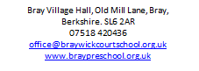
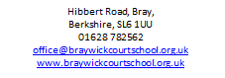

Phone: 01628 782562
E-mail: recruitment@braywickcourtschool.org.uk

Due to the expansion of our preschool, we are looking to broaden our current team. We are recruiting for motivated, caring staff in multiple roles, including:
Preschool Leadership
Early Years Practitioners
Early Years Assistants
Monday to Friday inclusive, term time only
Positions available from April or September 2021

Visits to the preschool prior to submitting an application are warmly welcomed and strongly encouraged. Please contact us for further details and an application pack.

Closing date: 10am, Monday 26th April 2021
Interviews and other recruitment tasks: week commencing 3rd May

The school is committed to safeguarding and promoting the welfare of children and expects all staff and volunteers to share this commitment. All appointments are subject to satisfactory references, pre-employment medical check and DBS check. Braywick Court School will welcome a diverse population of both children and staff and is committed to promoting and developing equality of opportunity in all its functions.

