Braywick Court School Education Continuity Plan

Completed By | Gemma Donnelly & Michelle Robertson  In consultation with all staff and latest DfE guidance  Shared with and approved by LAB and BPET
 | September 2020

In the DfE’s Guidance for Full Opening: Schools (latest update 7 September 2020), the following is stated:

Where a class, group or small number of pupils need to self-isolate, or there is a local lockdown requiring pupils to remain at home, we expect schools to have the capacity to offer immediate remote education. Schools are expected to consider how to continue to improve the quality of their existing offer and have a strong contingency plan in place for remote education provision by the end of September. This planning will be particularly important to support a scenario in which the logistical challenges of remote provision are greatest, for example where large numbers of pupils are required to remain at home.

Government guidance for contingency planning in areas of local lockdowns was published on 28th August. Restrictions in education settings are to be based on a system of four tiers which are intended as measures of "last resort" in those areas subject to local restrictions. These are as follows:

Tier 1: fully open to all pupils full time, with face coverings required in corridors and communal areas for settings with pupils in Year 7 and above.
Tier 2: Secondary schools and colleges to use rotas to help break chains of transmission, though vulnerable young people and the children of critical workers will be allowed to attend full time; a similar model will apply to FE providers. The 'face covering in communal areas' rule will apply (settings with pupils in Year 7 and above). Primary schools, early years, special schools, AP providers and other specialist settings remain open to all pupils (guidance on planning a tier 2 rota model has been published).
Tier 3: Childcare, nurseries, primary schools, AP, special schools and other specialist settings remain open. Secondary schools, FE colleges and other educational establishments will remain open for vulnerable young people, the children of critical workers and selected year groups (to be identified by the DfE). Remote education to be provided for other pupils. The 'face covering in communal areas' rule will apply for those on site (settings with pupils in Year 7 and above).
Tier 4: All nurseries, childminders, mainstream schools, colleges and other educational establishments will remain open to vulnerable children and the children of critical workers only. AP, special schools and other specialist settings will allow for full-time on-site attendance. Remote education to be provided for all other pupils. The 'face coverings in communal areas' rule will apply (settings with pupils in year 7 and above).

Teaching & Learning
Short Term Isolation of a Pupil (Up to 1 week)
Intent | Implementation | Resources | Intended Impact | Review Date
Pupil in short term self-isolation  (up to 1 week) with Covid-19 symptoms are able to have access to educational provision until their return to school. | EYFS  - Join assembly via Zoom  - Grab and Go packs sent home with children  - Parents given a suggested list of online learning activities they can complete whilst at home. | Grab & Go Packs:  - Maths & phonics resources e.g. number track, tens frame, phonics mat  Online Activities:  - Purple Mash  - Bug Club  - Phonics Play  - YouTube storytime | Continuity of education for all pupils.  Gaps in learning minimised. | October 2020
 | KS1  - Join assembly via Zoom  - Grab and Go packs sent home with children  - Current Power Maths book sent home with child  - Parents given a suggested list of online learning activities they can complete whilst at home. | Grab & Go Packs:  - number track, tens frame, phonics mat, Spelling & handwriting worksheets, reading comprehension exercise  Online activities:  - Spelling Shed  - Bug Club  - Purple Mash  - Maths Shed  - Phonics Play  - YouTube storytime  - Nessy | Continuity of education for all pupils.  Gaps in learning minimised. | October 2020
 | KS2  - Join assembly via Zoom  - Grab and Go packs sent home with children.  - Current Power Maths book sent home with child  - Parents given a suggested list of online learning activities they can complete whilst at home | Grab & Go Packs:  - number track, tens frame, phonics mat, Spelling & handwriting worksheets, reading comprehension exercise  Online activities:  - Spelling Shed  - Bug Club  - Purple Mash  - Maths Shed  - TT Rockstars  - Nessy | Continuity of education for all pupils.  Gaps in learning minimised. | October 2020
Whole Class or Bubble isolate for extended period due to advice from the Local Health Protection Team
Intent | Implementation | Resources | Intended Impact | Review Date
A whole class or bubble are learning at home in self-isolation (up to and beyond 2 weeks) with access to enhanced educational provision until their return to school. | EYFS  - All pupils and staff can join assembly via Zoom  - Daily learning for key lessons posted onto Edmodo to parents to access:  - Phonics  - Maths  - One other curriculum area  - Daily zoom ‘live lesson’ at least once a day in groups of up to 10  - Parents to submit work via Edmodo  - Class emails manned daily for parents to contact staff if necessary  - Wellbeing check ins with vulnerable & SEND pupils. | Online learning platforms to aid delivery of curriculum:  - WRH Maths  - Oak Academy Trust  - BBC Teach  - Phonics Play  - Purple Mash  - Power Maths | All pupils continue to be taught a wide range of subjects and receive a high-quality education.  Remote learning is high-quality and safe, and aligns as closely as possible with in-school provision. | October 2020
 | KS1  - All pupils and staff can join assembly via Zoom  - Daily learning for key lessons work posted onto Edmodo to parents to access:  - Maths  - English  - Phonics (Y1)  - One additional curriculum area  - Pupils expected to continue to read daily.  - Daily zoom ‘live lesson’ at least once a day  - Parents to submit work via Edmodo  - Class emails manned daily for parents to contact staff  - Wellbeing check ins with vulnerable & SEND pupils. | Online learning platforms to aid delivery of curriculum:  - WRH Maths  - Oak Academy Trust  - BBC Teach  - Phonics Play  - Purple Mash  - Power Maths  - Nessy | All pupils continue to be taught a wide range of subjects and receive a high-quality education.  Remote learning is high-quality and safe, and aligns as closely as possible with in-school provision. | October 2020
 | KS2  - All pupils and staff can join assembly via Zoom  - Daily learning for key lessons work posted onto Edmodo to pupils to access:  - Maths  - English  - At least one additional curriculum area  - Pupils expected to continue to read daily.  - Daily zoom ‘live lesson’ at least once a day  - Pupils to submit work via Edmodo daily  - Teachers to review work via Edmodo and provide feedback to pupils either via Edmodo and/or during live teaching sessions  - Wellbeing check ins with vulnerable & SEND pupils.  - Class emails manned daily for parents to contact staff | Online learning platforms to aid delivery of curriculum:  - WRH Maths  - Oak Academy Trust  - BBC Teach  - Phonics Play  - Purple Mash  - TT Rockstars  - Power Maths  - Nessy | All pupils continue to be taught a wide range of subjects and receive a high-quality education.  Remote learning this is high-quality and safe, and aligns as closely as possible with in-school provision. | October 2020
Local or National Lockdown closes BCS to all pupils.
Intent | Implementation | Resources | Intended Impact | Review Date
BCS to provide education for key worker and vulnerable pupils. | - Extended schools’ team to facilitate remote learning for key worker and vulnerable pupils 9am-3pm.  - Remote learning plan (as above) to continue for all pupils and to be accessed by Key Worker and vulnerable pupils in school. | DB & RR working in school with key worker & vulnerable pupils. | Key worker & vulnerable pupils to have access to remote learning, supported by BCS staff.  Key worker parents to continue to work despite lockdown. | October 2020
Staff to ensure that all pupils are safeguarded against potential risk or harm in the event of school closure. | - Designated Safeguarding Lead and Deputy to be available by phone and email if a safeguarding concern should arise.  - All staff to have received training in the use of CPOMS | CPOMS  MR & GD | Lockdown and school closure does not impede the reporting and management of safeguarding.  All members of the school community to be kept safe whilst school is closed. | October 2020
Targeted Support for Specific Groups
Intent | Implementation | Resources | Intended Impact | Review Date
All pupils to have access to the technology they need to be able to learn effectively at home. | - Office to compile a list of parents who may need access to school devices.  - Laptops, iPads and kindles to be offered to priority families  - Funding applied for to purchase additional devices in the event of wider school or local lockdown. | Inventory of resources  Audit of vulnerable parents  Laptops  iPads  Kindles  Part funded by profit from holiday club | Disadvantaged pupils are able to access home learning material at home. | October 2020
Pupils with SEND to confidently engage with, and not be disadvantaged by, home learning. | - 1:1 support staff to make daily contact with SEND pupils who are isolating at home via phone and/or zoom.  - Home learning work set to takes into account the individual needs of SEND pupils and to ensure that their needs are met whilst learning remotely.  - SEND pupils to be set up as a bespoke group on Edmodo platform, to allow for differentiation of home learning tasks.  - Teachers to have a weekly check in with SENDCo to monitor provision for SEND pupils. | Daily scheduled zoom/phone calls for 1:1 staff with SEND pupils.  Support staff training and access to Edmodo | Parents of SEND pupils to have sufficient support to assist their child with home learning.  SEND pupils to have access to high quality education which meets their needs. | October 2020
Wider School Needs
BCS is able to remain fully operational in the event of short-term isolation of staff (up to 1 week). | 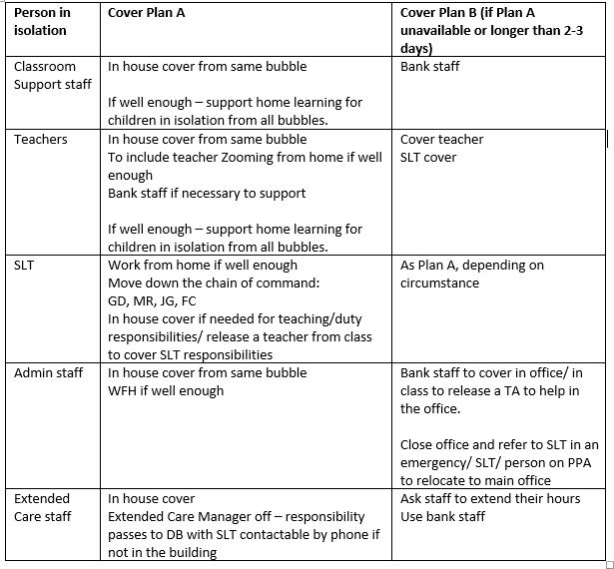 | Assigned budget for additional staffing needs.  DBS and recruitment checks for all bank staff.  Induction for all bank staff. | All staff to have a clear understanding of contingency planning in the event of staff absence.  Pupils’ learning is not disrupted due to staff self-isolating. | October 2020

Online resources to support pupil’s learning.
Spelling Shed | Maths Shed | Bug Club
Spelling practice: Years 1- 6  www.play.edshed.com or via Spelling Shed app | Maths skills: Years 1- 6  www.play.edshed.com or via Maths Shed app | Reading & Comprehension: EYFS - Year 6  https://www.activelearnprimary.co.uk/login
TT Rockstars | Phonics Play | Nessy *
Multiplication Tables: Years 3-6  https://ttrockstars.com or via TT Rockstars app | Phonics practice: EYFS -Year 2  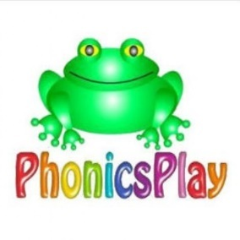  https://www.phonicsplay.co.uk/  Username: march20 Password: home | Reading & spelling practice: Years 1-6  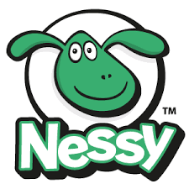  https://www.nessy.com/uk/ or via Nessy App
Edmodo | Purple Mash | BCS YouTube
Online Learning Portal: EYFS – Year 6  https://new.edmodo.com/ or via Edmodo app | Online Learning Portal: EYFS – Year 6  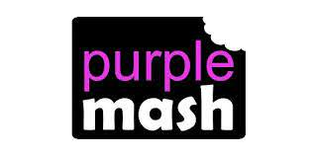  https://www.purplemash.com/sch/braywickcourt  (google chrome is the best browser for purple mash) | Online Learning Portal: EYFS – Year 6  https://www.youtube.com/channel/UCIHhtw3wR_bTXrZmA-VR9bQ

