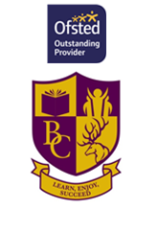

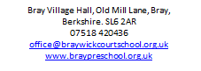
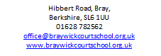

UNIFORM

We are proud to offer T-shirts, sweatshirts and legionnaires hats for sale bearing our pre-school logo.

It is not compulsory for the children to wear them, but we like to encourage it as it helps the children to feel part of a group and it saves spoiling all their other clothes!

If you would like to place an order, please complete the form below return to office@braywickcourtschool.org.uk

Childs Name

 | Quantity |  | Description | Size | Price | Sub Total
 |  |  | T-Shirt | XSM 2/3 | £6.95
 |  |  | T-Shirt | SM 3/4 | £6.95
 |  |  | T-Shirt | LG 5/6 | £6.95
 |  |  | Sweatshirt | SM 3/4 | £9.95
 |  |  | Sweatshirt | LG 5/6 | £9.95
 |  |  | Legionnaires Hat | ONE SIZE | £5.00
 |  |  |  |  | TOTAL

Bank transfer total due to;
30-65-41 33257968 clearly stating your Childs name and UNIFORM.
Once confirmation has been received your order will be placed.
Thank you

