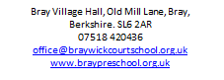
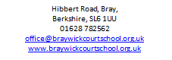

Phone: 01628 782562
E-mail: recruitment@braywickcourtschool.org.uk

We are recruiting for
Classroom & Early Years Assistants

We are looking for flexible people to join our bank staff, working across both our settings.
A variety of shifts are available, both short term and ad hoc.
Qualifications and experience are desirable but not essential.
Contact us for more information and an application pack.
Applications will be considered on receipt.

The school is committed to safeguarding and promoting the welfare of children and expects all staff and volunteers to share this commitment. All appointments are subject to satisfactory references, pre-employment medical check and DBS check. Braywick Court School will welcome a diverse population of both children and staff and is committed to promoting and developing equality of opportunity in all its functions.

